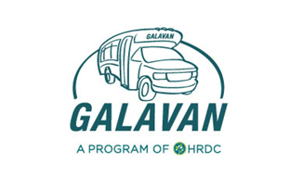
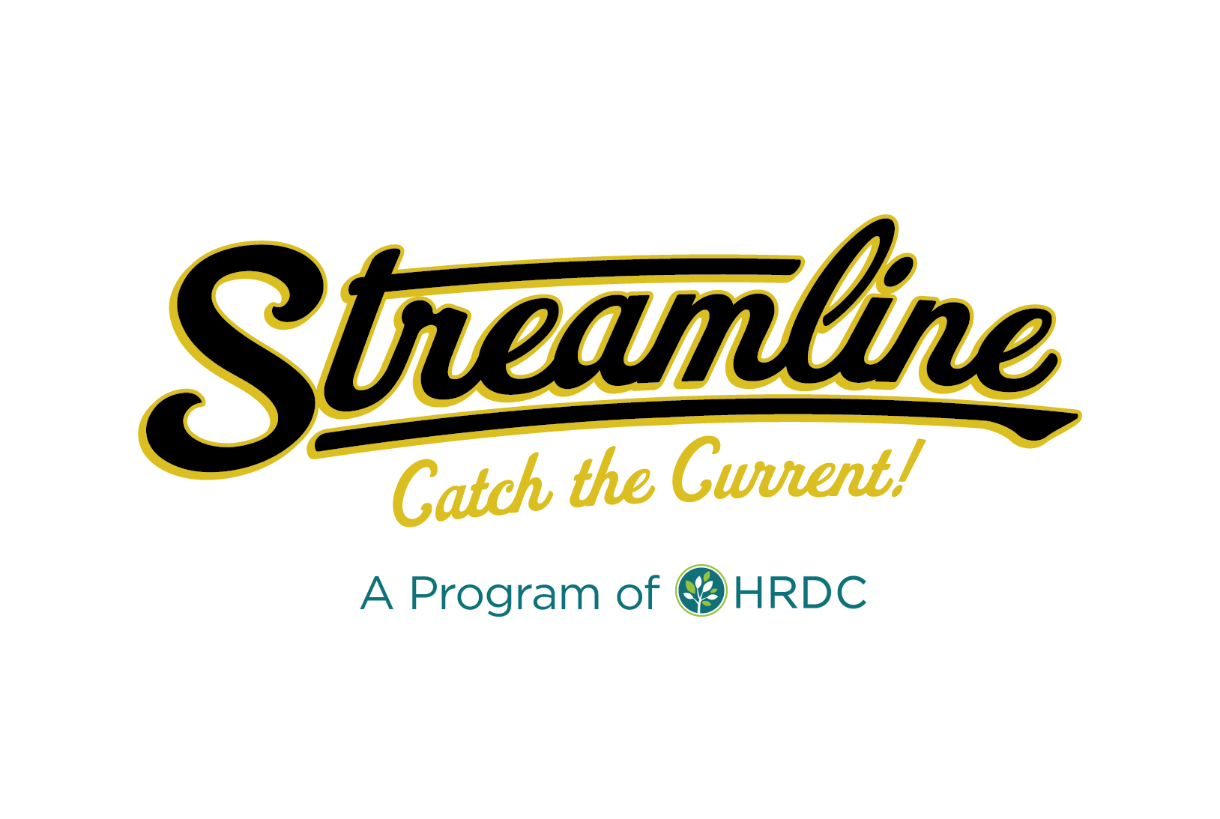
Streamline/Galavan Advisory Board
Marketing Meeting Agenda 12/15/2020
Zoom Meeting - 8:30 a.m. to 10 a.m.
https://zoom.us/j/6215759599
Call In: 1-669-900-6833
Meeting ID: 621 575 9599 followed by #
Participant ID: #

Attendees: Sunshine Ross, Vanessa Palmer, David Kack, Jennifer Boyer, Dennis Sines, Craig Ollinger, Tracy Menuez
Purpose of Meeting:
- Discuss New Streamline Sponsorship Program
- Discuss Changing Terminology from Fare-Free to Zero-Fare
- Discuss Communication Plan for New Routes
Prior to the official start of the meeting, David offered comments related to the potential Gallatin County Fairgrounds FLAP grant. The fairgrounds board seems to be interested in this project.
Jennifer mentioned that during the PCC meeting last week, County Commissioner Don Seifert brought up the future UTD as they were discussion the Transportation Plan for the Triangle Area.
David also brought up the National Science Foundation Connected Cities project that we may want to investigate further. The application is due February 24th, 2021. Our application could include combining our bus tracking with the Ride Amigos software into one platform. We would also need to tie in Gallatin County and Skyline.
Discussion Items:
- Discuss New Streamline Sponsorship Program
  - Discuss Purpose
  - Review Difference between Mission & Vision Statements
  - Discuss Streamline Mission & Vision
  - Discuss Pillars & Pillar Statements
Sunshine thanked everyone for joining the meeting and shared that she would like the marketing committee to take a more active role in the upcoming months. The operations committee doesn’t have much going on at the moment, so this is a good time to shift gears and prepare for this fall. The purpose of the Streamline Sponsorship program is to be intentional about what we allow in the buses. HRDC, as a nonprofit, files Form 990, which exempts the organization from paying taxes on revenue. This exception covers advertising revenue (but only up to a certain threshold). The new Sponsorship program seems to be the best way to comply with our tax exemption status and to comply with the City of Bozeman advertising restrictions.

Sunshine then gave an overview of the new Streamline sponsorship program. Bozeman Health is currently our one sponsor as they gave Streamline at $10,000 donation in FY2020. They are expected to give a $10,000 - $20,000 donation in FY2021.
As Sunshine/Vanessa recruit sponsors for the program, they wanted Streamline to have a very set mission, vision, and values/pillars. New sponsors will be required to show how they support us in at least one of those pillars.
Vanessa gave a brief overview of how to create a mission statement and a vision statement.
Sunshine shared HRDC’s mission and vision statement with the marketing committee and then shared Streamline’s current mission statement, which reads, “Streamline exists to be the provider of mobility services and alternatives to the single occupancy vehicle in southwest Montana."
TMD, Streamline’s consultant for the route redesign suggested the following new mission statement, “Streamline exists to provide safe, cost-effective, and reliable transportation services that support the social, economic, and environmental well-being of the community by providing access to education, employment, public service, healthcare, shopping, and recreational opportunities.”
Sunshine and Vanessa also proposed the following new vision statement, “We envision a community where public transportation is easy to use, widely available, and strongly integrated into the everyday lives of residents.”
David suggested shortening the mission statement by replacing the end with “by providing access to all of life’s opportunities.” David also mentioned that the release of a new mission/vision statement works well with the upcoming 15th year anniversary, Redesign Streamline 2020, and UTD efforts.
Sunshine then went over the proposed values/pillars: environmental sustainability, health & wellness, economic opportunity, social equity, and personal autonomy. David asked if we could change wording of autonomy to independence.
As part of value statements, David suggested including facts about transportation being the 2nd highest household cost per month after housing (economic opportunity). Sunshine said that public transportation increases property values and links people to jobs/education (economic opportunity).
For personal independence, public transportation enables individuals to get out and live their lives regardless of mobility type or ability to pay.
David asked about in-bus railing infrastructure in new buses. Sunshine said that railing is currently in Gilligs and will likely be in new El Dorados.
Sunshine showed an infographic that Vanessa made about Streamline’s commitment to environmental sustainability. She told the committee that we plan to develop similar infographics for the other pillars. We will distribute these at events, on social media, etc. David mentioned that we could also develop an image that shows how many cars could fit on a downtown block versus how many people could ride a bus downtown.
Jennifer wondered if we could also develop pillars on the delivery side of Streamline. For example, we could use terms like safe, cost-effective, quick, etc. Sunshine said she would like to include these terms in the pillar statements.
- Discuss shift from Fare-Free to Zero-Fare
  - Discuss Need for the Change in Language
  - Highlight Zero Fare Partners
Sunshine discussed that Streamline may want to switch its current “fare-free” language to “zero-fare.” Many other systems use the zero-fare language since “free” is often associated with poverty or college students. Free is not the best terminology to use when looking to gain choice riders. Vanessa said that based on her research, it seems like “zero-fare” is the preferred language for a system that does not charge a fare. Vanessa also mentioned that we can time this “zero-fare” roll out with the redesign materials. This next year is a great time to make this large changes.
Sunshine then mentioned we can then showcase our partners as “zero-fare partners.” Jennifer said it would be cool to have a statement that says, “Your ride is paid for by ______.” The end of this statement would then cycle through our different partners.

- Discuss Communication Plan
  - New Bus Stop Signage & Rebranding
  - Doors to Transit Project (Spring 2021)
  - Public Events/Presentations
  - Engaging Media Coverage
  - Walk Your City Wayfinding System
Sunshine gave the committee an overview of the communications plan for this upcoming year. We will be installing new signs, completing the Doors to Transit project again, hopefully doing public events including the BBQ, and engaging in media coverage. She also mentioned that we may want to consider doing a “Walk Your City” event.
David suggested that we celebrate the 3.5 millionth rider (whatever the number is) to get people excited. Sunshine said that is helpful to engage the reporter in the story as we look for media coverage.
Jennifer asked if we could do a social media and/or newspaper campaign where we highlight local people who ride the bus.
David suggested that we look for an MSU class who would be interested in helping us develop the new marketing materials. Sunshine also suggested we involve Champ. David said that he will send a list of professors to contact to Sunshine/Vanessa.
- Next Steps
  - Present Recommendations at Advisory Board meeting (Tues. 1/17 @ 8:30am)
Sunshine said that we will mention our meeting today at the next Streamline/Galavan Advisory Board meeting on January 17th.

