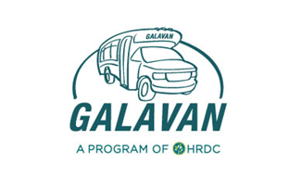
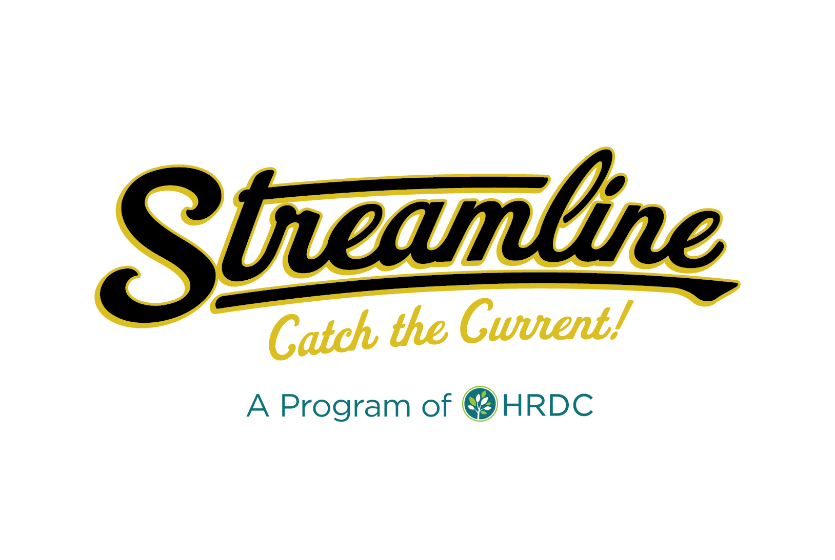
Streamline/Galavan Advisory Board
Marketing Meeting Agenda 12/15/2020
Zoom Meeting - 8:30 a.m. to 10 a.m.
https://zoom.us/j/6215759599
Call In: 1-669-900-6833
Meeting ID: 621 575 9599 followed by #
Participant ID: #

Purpose of Meeting:
- Discuss New Streamline Sponsorship Program
- Discuss Changing Terminology from Fare-Free to Zero-Fare
- Discuss Communication Plan for New Routes
Discussion Items:
- Discuss New Streamline Sponsorship Program
  - Discuss Purpose
  - Review Difference between Mission & Vision Statements
  - Discuss Streamline Mission & Vision
  - Discuss Pillars & Pillar Statements

- Discuss shift from Fare-Free to Zero-Fare
  - Discuss Need for the Change in Language
  - Highlight Zero Fare Partners

- Discuss Communication Plan
  - New Bus Stop Signage & Rebranding
  - Doors to Transit Project (Spring 2021)
  - Public Events/Presentations
  - Engaging Media Coverage
  - Walk Your City Wayfinding System

- Next Steps
  - Present Recommendations at Advisory Board meeting (Tues. 1/17 @ 8:30am)

