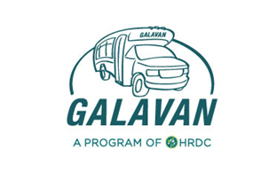
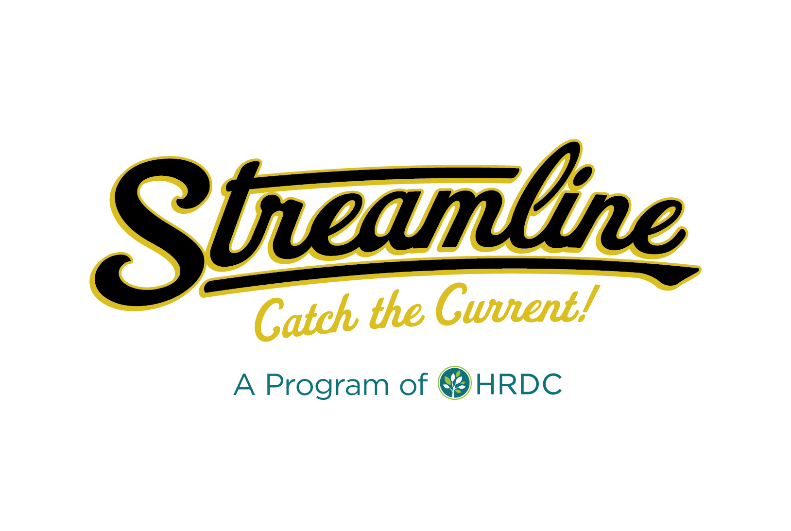
36Streamline/Galavan Advisory Board
Operations/Marketing Meeting Agenda 11/10/2020
Zoom Meeting - 8:30 a.m. to 10 a.m.
https://zoom.us/j/6215759599
Call In: 1-669-900-6833
Meeting ID: 621 575 9599 followed by #
Participant ID: #

Purpose of Meeting:
- Discuss Follow Up to TMD’s Initial Service Recommendations
- Review TMD’s Other Recommendations
- Discuss Communication Plan
Discussion Items:
- Follow up to TMD’s Service Recommendations (Ron Kilcoyne)
  - Review Proposed Weekend Service
  - Review Updates to Livingston based on rider feedback
  - Review Industry Standards for Distance between Bus Stops
  - Discuss Walk Shed or Catchment Area

- Review TMD’s Other Recommendations (Ron Kilcoyne)
  - Review Customer Experience Recommendations
  - Review Capital Recommendations

- Discuss Communication Plan (Sunshine Ross)
  - Doors to Transit Project (11/5 – 11/12)
  - Public Events/Presentations
  - Engaging Media Coverage
  - Walk Your City Wayfinding System

- Next Steps
  - Present Recommendations at Advisory Board meeting (Tues. 11/17 @ 8:30am)

